**Wireless Energy Harvesting for Internet of Things**

**Software:** NetSim Standard v14.1, Visual Studio 2022

**Project Download Link:**

<https://github.com/NetSim-TETCOS/WSN_Energy_Harvesting_Workspace_v13.1/archive/refs/heads/main.zip>

Follow the instructions specified in the following link to download and set up the Project in NetSim:

<https://support.tetcos.com/en/support/solutions/articles/14000128666-downloading-and-setting-up-netsim-file-exchange-projects>

**Introduction to Energy Harvesting:**

Among various methods like vibration, light, and thermal energy extraction, wireless energy harvesting (WEH) has proven to be one of the most promising solutions by virtue of its simplicity, ease of implementation, and wide availability. This technology trend is gaining attraction as it offers a fundamental approach to extend the lifespan of batteries. While harvesting from the environmental sources is dependent on the presence of the corresponding energy source, RF (radio frequency) energy harvesting provides unique advantages, being wireless and easily accessible from transmitted energy sources like (TV/radio broadcasters, mobile base stations, and handheld radios), It's cost-effective and allows for compact implementations.

**Components of a WEH-Enabled Sensor Device:**

A typical WEH-enabled sensor device comprises key components: an antenna, a transceiver, a wireless energy harvesting (WEH) unit, a power management unit (PMU), a sensor/processor unit, and optionally, an onboard battery.

**Calculation of Harvested Power (PH):**

The available Harvested power (PH) is determined by the Friis equation. It is directly proportional to Transmitted power (PT), Path loss (PL), Transmitter antenna gain (GT), Receiver antenna gain (GR), the Power conversion efficiency of the converter (PCEH), and the square of the wavelength (λ), and is inversely proportional to the square of the communication distance (r) between the source and the device.

**Energy Components and Distribution:**

The energy consumed by the device can be categorized into communication energy (listening, receiving, and transmitting) and computation energy (processing and sensing).

* Listening energy (ELS)
* Receiver energy (ERX)
* Transmitter energy (ETX)
* Processing energy (EPR)
* Sensing energy (ESN)

To capture the energy distribution among the aforementioned energy consumers, weighting coefficients, αLS> αTX> αRX > αPR> αSN are assigned to them. The total average energy consumption ED= αLSELS+ αTXETX+ αRXERX+ αPREPR+ αSNESN is then calculated as the sum of the product of these coefficients and their respective energy components.

**Battery Storage and Harvested Energy:**

The total energy stored in the device's battery is denoted as EB. On the other hand, the available harvested energy per active-duty cycle is represented by EH.

**Topology Considerations:**

We assume constant energy consumption for the receiver, processor, and sensor. However, the energy consumption of the transmitter (ETX) is directly proportional to the square of the distance (r2ij) ,where rij is the distance between the originating device (j) and the sink node (i), particularly in a ring topology or multihop topology.The harvested energy (EH) is inversely proportional to r2ij (here j is the sink node and rij = rji).

**IEEE Ref Paper:**

Wireless Energy Harvesting for the Internet of Things

P. Kamalinejad C. Mahapatra; Z. Sheng ; S. Mirabbasi ; V. C. M. Leung ; Y. L. Guan

*IEEE* COMMUNICATIONS MAGAZINE · JUNE 2015

**Real-World Context:**

The advent of technology has revolutionized the agricultural landscape, giving rise to Smart Agriculture Monitoring Systems (SAMS) that harness the power of advanced technology to optimize farming practices, enhance crop yields, and promote sustainable agriculture. This discussion focuses on the impact of energy harvesting on wireless sensor nodes within SAMS, utilizing NetSim as a simulation tool.

**Without Energy Harvesting**

Smart Agriculture Monitoring Systems (SAMS) without energy harvesting rely on traditional power sources, such as batteries, to operate wireless sensor nodes. These batteries have a limited lifespan and require periodic replacement, increasing maintenance costs and environmental concerns due to battery disposal. Additionally, battery depletion can lead to disruptions in data collection, affecting the effectiveness of SAMS in monitoring crop health and environmental conditions

**Figure 1:** Real world scenario for Smart agriculture system Without Energy harvesting

**With Energy Harvesting**

The integration of energy harvesting technologies into Smart Agriculture Monitoring Systems (SAMS) revolutionizes the system by introducing sustainable energy sources for wireless sensor nodes. This transformation offers several advantages, including reduced maintenance costs, enhanced environmental sustainability, and uninterrupted data collection. Energy harvesting eliminates the need for frequent battery replacements, significantly lowering maintenance expenses. By minimizing battery usage, Continuous power supply from energy harvesting ensures uninterrupted data collection from wireless sensor nodes, providing real-time insights into crop health and environmental conditions.

**Figure 2:** Real world scenario for Smart agriculture system With Energy harvesting

**Wireless Energy Harvesting overview**

* WEH significantly extends the operational lifespan of IoT devices, reducing the frequency of battery replacements and associated maintenance costs.
* By eliminating the need for frequent battery replacements, WEH minimizes maintenance expenses and enhances the overall efficiency of IoT networks.
* WEH promotes environmental sustainability by reducing battery usage and disposal, mitigating the environmental impact of IoT devices.
* WEH facilitates the deployment of IoT devices in remote or inaccessible areas, expanding the reach of IoT networks and providing valuable insights into diverse environment

**The Role of NetSim Simulator**

NetSim serves as a valuable tool for assessing the effectiveness of energy harvesting technologies in wireless sensor networks. By providing a comprehensive simulation environment, NetSim enables researchers and engineers to evaluate various system parameters and optimize energy harvesting performance. This capability empowers them to compare the performance of wireless sensor networks with and without energy harvesting, assess the impact of energy harvesting efficiency, optimize energy harvesting placement, analyze the impact of energy harvesting on network stability, and investigate the scalability of energy harvesting. Through these simulations, NetSim plays a critical role in developing optimized and sustainable solutions for wireless sensor networks.

**COMPARATIVE ANALYSIS:**

1. The **Energy_Harvesting_IOT_Workspace** includes sample network configuration files, namely Without-energy-harvesting and With-energy-harvesting, which are pre-saved.

**Figure 3:** Sample configuration files

1. We will now open the **“Without-Energy-Harvesting”** sample.
2. The network scenario consists of 16 sensors, a LoWPAN Gateway, a Router and a Wired Node as shown below.

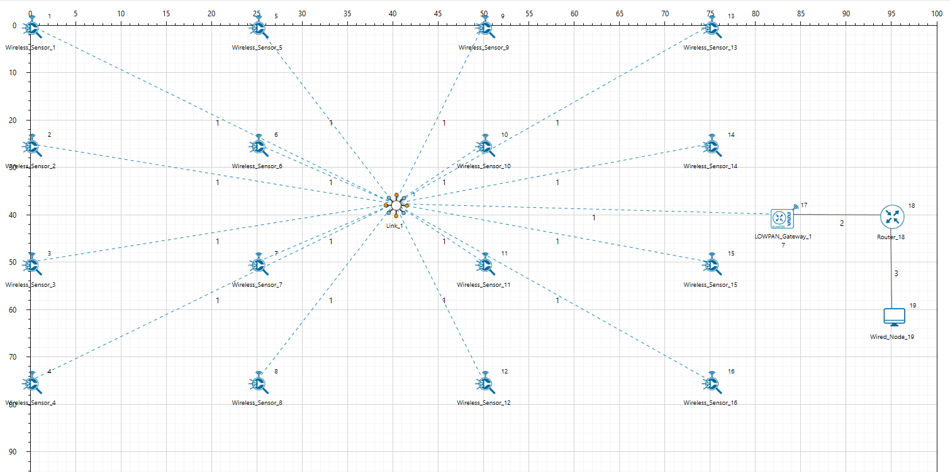

**Figure 4:** Energy Harvesting Network Topology

1. Here, the Energy Harvesting parameter has been set to OFF in all Sensor nodes. To enable or disable the energy harvesting setting, users can navigate to Interface(ZigBee)->Physical layer -> IEE802.15.4 ->Power ->Set Power source to Battery of the sensor nodes, as shown below

**Figure 4:**Energy Harvesting parameter

1. Run Simulation for 100 seconds and save the simulation results.

**Results and Discussion**

Once the simulation is complete, the NetSim result dashboard will open. From there, navigate to the additional metrics section and select the Battery model under IEEE802.15.4_Metrics. This will display the Battery model table.

**Figure 5:** Battery model table from Netsim result dashboard

**WITHOUT ENERGY HARVESTING:**

In the Battery model table, you can observe the results for scenario without energy harvesting. This table provides detailed insights into the energy consumption of each sensor node

**Figure 6:** Battery model table without energy harvesting

**WITH ENERGY HARVESTING:**

Now, open and run the 'With-Energy-Harvesting' sample, where Energy Harvesting is enabled for all sensor nodes. Upon comparing the remaining energy levels with the “without-energy-harvesting” Scenario, you will observe increases in the working capability of sensors

**Figure 7** : Battery Model table with energy harvesting

Simulations can be performed for different values of EH Fraction which may vary as per the efficiency of the Energy Harvesting unit.

**Note:** You can observe slight variation in the remaining energy with and without energy harvesting as the simulation time is in seconds.

**Appendix: NetSim source code modifications**

**Changes to Battery Model.h within Battery Model project**

/* We implemented the Batter Model*/

#ifndef _NETSIM_BATTERY_MODEL_H_

#define _NETSIM_BATTERY_MODEL_H_

#ifdef __cplusplus

extern "C" {

#endif

#ifndef _BATTERY_MODEL_CODE_

#pragma comment(lib,"BatteryModel.lib")

typedef void* ptrBATTERY;

#endif

_declspec(dllexport) ptrBATTERY battery_find(NETSIM_ID d,

NETSIM_ID in);

_declspec(dllexport) void battery_add_new_mode(ptrBATTERY battery, int mode, double current, char* heading);

_declspec(dllexport) ptrBATTERY battery_init_new(NETSIM_ID deviceId, NETSIM_ID interfaceId, double initialEnergy, double voltage, double dRechargingCurrent);

_declspec(dllexport) bool battery_set_mode(ptrBATTERY battery, int mode, double time);

_declspec(dllexport) void battery_animation();

_declspec(dllexport) void battery_metrics(PMETRICSWRITER metricsWriter);

_declspec(dllexport) double battery_get_remaining_energy(ptrBATTERY battery);

_declspec(dllexport) int battery_energy_harvesting(ptrBATTERY battery, double eh_energy);

_declspec(dllexport) double battery_get_consumed_energy(ptrBATTERY battery, int mode);

#ifdef __cplusplus

}

#endif

#endif //_NETSIM_BATTERY_MODEL_H_

**Changes to double battery_get_remaining_energy (), Battery Model.c within Battery Model project**

_declspec(dllexport) double battery_get_remaining_energy(ptrBATTERY battery)

{

return battery->remainingEnergy;

}

_declspec(dllexport) int battery_energy_harvesting(ptrBATTERY battery, double eh_energy)

{

double eh_energy_mJ = eh_energy * ((pstruEventDetails->dEventTime - battery->modeChangedTime) / 1000000);

battery->remainingEnergy += eh_energy_mJ;

}

**Changes code to ChangeRadioState.c, within Zigbee project at the end of the file**

#define EH_FRACTION 0.1

// EH_FRACTION is the fraction of the received signal energy that can be

// captured and harvested by the sensor.

int calculate_eh(NETSIM_ID dev1, NETSIM_ID dev2)

{

double rx_pwr = GET_RX_POWER_mw(dev1, dev2, pstruEventDetails->dEventTime);

double eh_energy = EH_FRACTION * rx_pwr;

ptrBATTERY battery = WSN_PHY(dev2)->battery;

if (battery)

battery_energy_harvesting(battery, eh_energy);

}

**Changes code to int fn_NetSim_Zigbee_Run(),** 802_15_4.c file**, within Zigbee project**

case UPDATE_MEDIUM:

{

double dtime=pstruEventDetails->dEventTime;

NETSIM_ID nLink_Id, nConnectionID, nConnectionPortID, nLoop;

NETSIM_ID nTransmitterID;

nTransmitterID = pstruEventDetails->nDeviceId;

ZIGBEE_CHANGERADIOSTATE(nTransmitterID, WSN_PHY(nTransmitterID)->nRadioState, RX_ON_IDLE);

if(WSN_PHY(nTransmitterID)->nRadioState != RX_OFF)

WSN_MAC(nTransmitterID)->nNodeStatus = IDLE;

nLink_Id = fn_NetSim_Stack_GetConnectedDevice(pstruEventDetails->nDeviceId,pstruEventDetails->nInterfaceId,&nConnectionID,&nConnectionPortID);

for(nLoop=1; nLoop<=NETWORK->ppstruNetSimLinks[nLink_Id-1]->puniDevList.pstruMP2MP.nConnectedDeviceCount; nLoop++)

{

NETSIM_ID ncon = NETWORK->ppstruNetSimLinks[nLink_Id-1]->puniDevList.pstruMP2MP.anDevIds[nLoop-1];

if(ncon != pstruEventDetails->nDeviceId)

{

calculate_eh(nTransmitterID, nLoop);

WSN_PHY(ncon)->dTotalReceivedPower -= GET_RX_POWER_mw(nTransmitterID,ncon,pstruEventDetails->dEventTime);

if(WSN_PHY(ncon)->dTotalReceivedPower < WSN_PHY(ncon)->dReceiverSensivity)

WSN_PHY(ncon)->dTotalReceivedPower = 0;

}

}

This completes the code modifications for energy harvesting.